- DIET RECOMMENDATION-DISEASE
AIM
To write a Prolog program to suggest a suitable diet based on a given disease using facts and rules.
OBJECTIVE
- To create a disease–diet knowledge base in Prolog.
- To associate diseases with appropriate diet types.
- To use Prolog rules to retrieve diet suggestions.
- To understand knowledge representation and logical inference.
ALGORITHM
- Start.
- Define diseases and their corresponding diet types as facts.
- Define the suggest_diet rule.
- Enter the disease as a query.
- Search the database for the matching disease.
- If a match is found, retrieve the corresponding diet.
- Display the suggested diet.
- Stop.
FLOWCHART
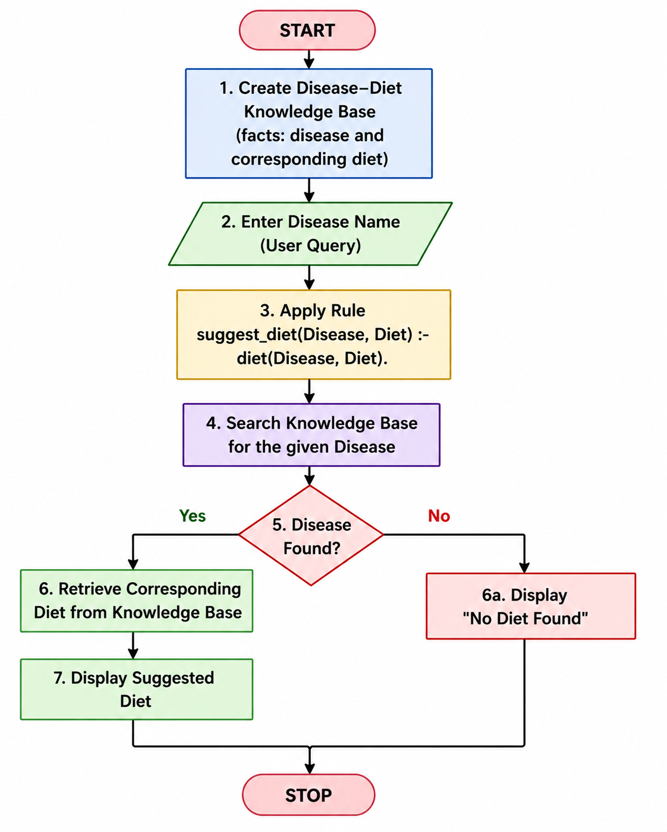
OUTPUT
diet(diabetes, low_sugar).
diet(hypertension, low_salt).
diet(obesity, low_calorie).
diet(anemia, iron_rich).
diet(heart_disease, low_fat).
suggest_diet(Disease, Diet) :-
diet(Disease, Diet).
OUTPUT
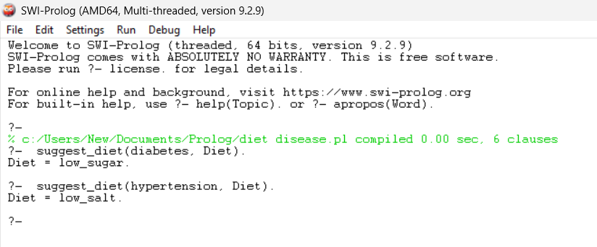
RESULT
Thus, the Prolog program was successfully implemented to suggest a diet based on the given disease, and the appropriate diet was retrieved using Prolog queries.

